History: Captain James cook

* Captain James Cook was a famous English sea captain and explorer.
* He was born in 1728 and died in 1779.
* He was born in Marton near Middlesbrough and then moved to Great Ayton.
* He joined the Royal Navy in 1755 and learned about navigation and map drawing.
* In 1770, Captain James Cook and his crew sailed the HMS Endeavour and discovered Australia, New Zealand and Tahiti.
* He completed 3 voyages and died whilst still on his 3rd voyage in Hawaii.

Other Explorers:

* Ibn Battuta
* Mathew Henson
* Felicity Aston
* Neil Armstrong
* Christopher Columbus 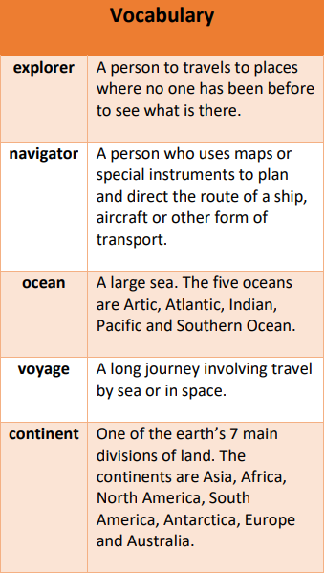

Where in the World?

Knowledge Organiser- Summer 2024

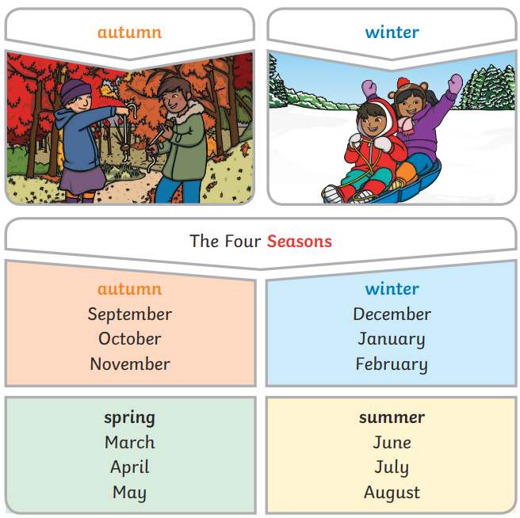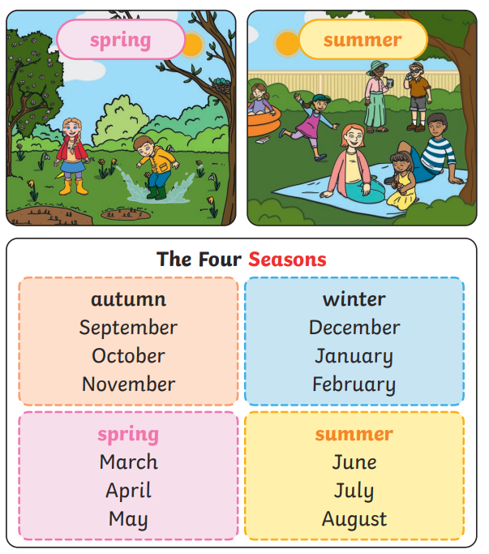

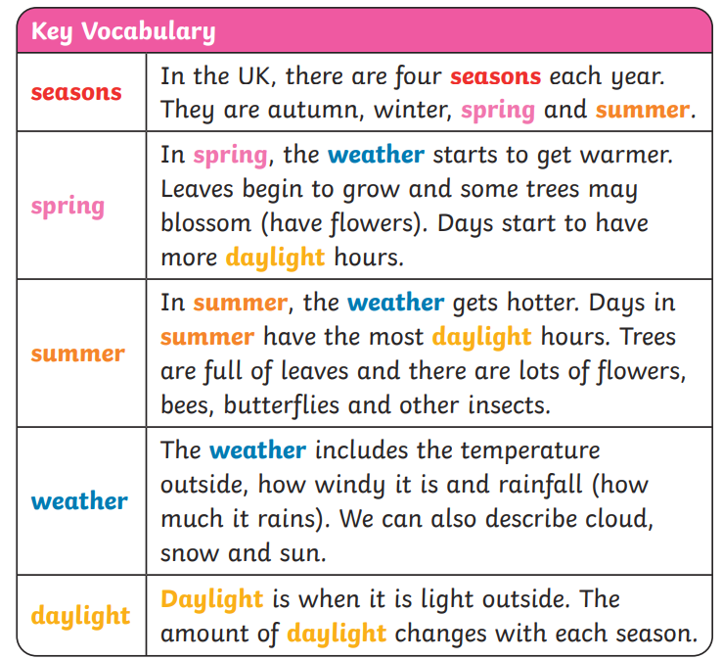

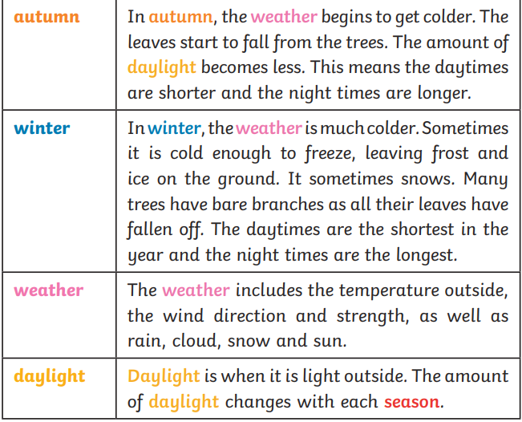

Science- Weather

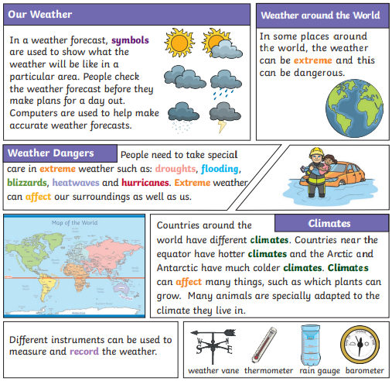

Geography

* There are seven continents: Africa, Antarctica, Asia, Australasia, Europe, North America and South America. Some continents have many countries, others do not.
* There are five oceans in the world: the Arctic Ocean, the Atlantic Ocean, the Indian Ocean, the Pacific Ocean and the Southern Ocean
* Countries around the world have different climates. Climates can be sorted into the following zones: warm, cold (or polar), tropical and temperate. Countries near the equator tend to have a hotter climate. Different animals are better suited to living in countries with a particular climate.
* The equator is an imaginary line drawn around the middle of Earth, dividing it into the Northern and Southern Hemispheres.
* The climate is usual weather conditions of an area.

Art

Portraits

A portrait is a picture of one person or a small group of people. People can make portraits in lots of ways, using different materials, techniques, equipment and colours. Artists may choose to create portraits of people they know or they may be paid to create a portrait of somebody. An artist often tries to show the person’s character so a portrait might show how important, kind or strong someone is.

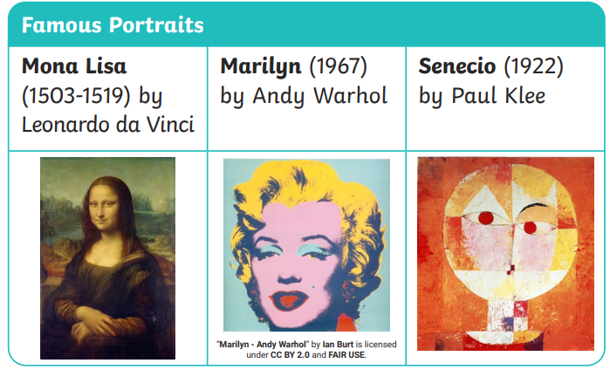

*Design Technology*

Soup

• Children will try a range of Soups with a variety of textures to decide what to include in their own soup, noticing what flavours go well together.

• The Children will create their ideas based on a design criteria.

• Children will learn the bridge, claw and fork secure way of cutting.

• They will learn to use a vegetable peeler and grater. They will understand where a range of fruit and vegetables come from and understand the principles of a varied diet.

• Children will evaluate each other’s product and give suggestions for improvement